A two-week meditation intervention of low or high body-focus does not grant the ability to sense the resting heart rate

Tim Palmer, Clémence Alméras, Josh Marquez, ?Legrand, ?Allen, Elsa Fouragnan*, Jacqueline Scholl*XX

Affiliations
JS: Université Claude Bernard Lyon 1, CNRS, INSERM, Lyon Neuroscience Research Centre (CNRL) U1028 UMR5292, PsyR2 team, Centre Hospitalier Le Vinatier, Bron, France

*These authors jointly supervised the work

Abstract
Meditation techniques have been identified as relating differently to mental health outcomes, challenging experiences (e.g. anxiety, somatic effects, and psychotic-like experiences) and cognitive and emotional processes. Our aim was to better understand the differential relationship between ‘low body focused’ and ‘high body focused’ meditation techniques with psychotic-like experiences (PLEs), mystical experiences and interoception. To achieve this, we employed a lab-based test of interoceptive awareness (two-alternative forced choice heartrate perception task requiring comparing of perceived heartrate to a subsequent series of auditory beeps), and psychometric survey of PLEs, mystical experiences and interoception in a counterbalanced within-subject intervention study. 26 participants were assigned to practice a meditation with high or low body focus for two weeks at home using audio guidance. We did not find any significant differences between the low vs high body focused technique intervention for task-based or questionnaire measures for interoception, PLEs or mystical experiences. Further analysis suggested that on the group level, participants’ trial-wise responses were only influenced by the auditory external cue and not their heart rate. This suggests that heart rate perception at rest is very difficult fo participants, even after undergoing a body-focused meditation training. In conclusion, a short-term high vs low body focus meditation did not differentially affect markers of interoception, psychotic-like or mystical experiences.

Introduction

There are multiple meditation techniques with different cognitive and emotional effects (Dahl et al., 2015; Nash & Newberg, 2023), embodied processes (Matko & Sedlmeier, 2019), and neural effects (e.g. Fox et al., 2016). This variation might explain why meditation has been associated with both benefits to mental health (e.g. Goyal et al., 2014; Zou et al., 2018), as well as challenges (e.g. Farias et al., 2020; Palmer et al., 2024; Schlosser et al., 2019). We previously found that techniques differing in body-focus correlated differently with the prevalence of psychotic-like experiences, mystical experiences and self-reported interoceptive awareness (Palmer et al., 2024). Here, we used an intervention study to test the causal impact of high vs low body focus meditation on these factors.

We employed two meditation techniques for our intervention, one with a high body focus (‘body scan’) and one with a low body focus (‘self enquiry’). For simplicity we refer to the high body focus technique as ‘CDM’ because it aligns with the ‘cognitive directed methods’ category of Nash et al’s (2013) taxonomy of meditation, and the low body focused technique as ‘NDM’ because it aligns with the ‘null directed methods’ category of this taxonomy. The Nash et al (2013) taxonomy divides meditation techniques based on the ‘intended end meditative state’ that the technique seeks to achieve. These enhanced states fall into three categories including ‘enhanced affective state’, ‘enhanced cognitive state’ and ‘enhanced non-cognitive/Non-affective state’ (Nash et al., 2013). A technique associated with an enhanced cognitive state is described as a ‘cognitive directed method’ (CDM), an affective state as an ‘affective directed method’ (ADM), and a non-cognitive/non-affective state as a ‘null directed method’ (NDM). In an alternative classification approach, Matko et al (2019: 2021) distilled meditation techniques to a list of fifty that describe what the mediator does whilst practicing the technique. Taking the top twenty most popular methods they applied multidimensional scaling to cluster techniques according to similarity ratings by experienced meditators, which resulted in a two-dimensional solution dividing techniques (Matko et al., 2021; Matko & Sedlmeier, 2019). These were ‘amount of body-focus’ describing the focus upon bodily sensory signals, and ‘activation’ describing how active or passive a meditation technique was, with those high on the activation dimension requiring more movement (Matko & Sedlmeier, 2019). The two techniques we chose here fall on the two extreme ends of the ‘amount of body orientation’ spectrum, that we refer to as ‘body-focus’.

Garfinkel et al (2015) suggest a tripartite approach to defining different measurements of interoception, including interoceptive sensibility, which measures the opinion of a persons’ interoceptive ability and how engaged they feel by interoceptive signals, captured via self-report measures, such as the Multidimensional Assessment of Interoceptive Awareness (MAIA). Secondly, interoceptive accuracy refers to the objective measure of the accuracy of a persons’ ability to detect their heartbeat (alternatively breathing rate e.g. Nikolova et al., 2022), measured via experimental tasks such as the heartbeat detection task (Legrand et al., 2022). Lastly, metacognitive awareness utilizes a measure of a persons’ confidence ratings of their heartbeat tracking judgements and relates this to the accuracy of their judgements, giving a measure of the insight they have about their own ability.

The practice of high body-focused meditation has been associated with significant increases on self-report measures of interoceptive awareness, including the MAIA. The MAIA has multiple subscales (see methods section for more details) which scores have been shown to increase following high body-focused meditation. For example, an 8-week Mindfulness Based Cognitive Therapy intervention (MBCT) led to significant improvements in scores on the Attention Regulation, Self-Regulation, Body Listening, and Trusting, associated with a reduction of psychological symptoms (i.e., experiential avoidance, rumination, self-efficacy, and self-discrepancy) (Pérez-Peña et al., 2022). Fissler et al (2016) found brief mindfulness training (awareness of body and breath) increased scores on the MAIA, reduced depressive symptoms, and that symptom reduction was mediated by increases in ‘decentering’. Bornemann et al (2015) found a 3-month high body-focused meditation intervention (‘body scan’ and ‘breath focused’) improved scores on the regulatory subscales of the MAIA, with the largest improvements seen in individuals with the lowest baseline scores. In a chronic pain population with comorbid depression, MBCT led to significant increases in the MAIA subscales Not Distracting and Self-Regulation compared to treatment as usual, with Not Distracting mediating reductions in depressive symptoms (De Jong et al., 2016). These studies suggest high body focused meditation (e.g. ‘body scan’ or ‘breath focused’) might foster a more trusting, attentive and regulatory relationship with bodily sensations. This points to the way in which people attend to bodily sensations being a key component of symptom improvement.

Interoceptive sensibility does not strongly correlate with interoceptive accuracy (e.g. heartbeat detection accuracy), and Khalsa et al (2008) found that meditators may score high on self-report measures, but low on measures of accuracy. As with sensibility, heartbeat accuracy can be improved through the practice of meditation (Bornemann & Singer, 2017; Jonathan R. Krygier et al., 2015). Bornemann and Singer (2017) found that a meditation program incorporating four types of meditation (‘body scan’, ‘breath focus’, ‘loving kindness’ and ‘open monitoring’) showed significant improvements on a heartbeat tracking task at 6 and 9 months compared to controls, with accompanying improvements in emotional awareness. Krygier et al (Krygier et al., 2015) found a 10-day intensive Vipassana meditation retreat (focused on ‘bodily sensations’ and ‘mental states’) led to significant improvements on heartbeat detection tasks. Khalsa et al (2020) failed to find any significant differences in heartbeat accuracy (measured via heartbeat detection task) between experienced meditators and non-meditators, and Melloni et al (2013) likewise found no difference between experienced meditators versus a short-term group using Mindfulness Based Stress Reduction (MBSR) for 8-weeks and a non-meditation control group. Therefore, improvements in accuracy appear more strongly related to a longer duration of meditation practice (e.g. Bornemann & Singer, 2017) and intensive retreats (e.g. Krygier et al., 2015).

Previously we found interoceptive awareness to moderate the relationship between NDM techniques and PLEs in a survey study (Palmer et al., 2024). For the current study we hypothesize that the high body focused technique (CDM) will enhance people's interoceptive awareness (compared to NDM). Alongside the lab-based test of interoceptive awareness (Cardioception task) (Legrand et al., 2022), we also used two questionnaire measures, the Multidimensional Awareness of Interoceptive Awareness 2 (MAIA2) (Mehling et al., 2018) and the Three Domain Interoception Sensations Scale (THISQ) (Vlemincx, E., Walentynowicz, M., Zamariola, G., Van Oudenhove, L., & Luminet, O., 2023). This design allows for a test of interoceptive accuracy and sensibility, with the Cardioception task also providing a measure of confidence in heartbeat detection, allowing a measure of ‘metacognitive awareness’.

Mystical experiences are altered states of consciousness characterized by feelings of connectedness to all living things, intense awe, positive mood, changes in time and space perception, and ineffability (Barrett et al., 2015; Roussel & Bachelor, 2000). They often involve ‘self-transcendent experiences’ marked by ego-dissolution and reduced self-salience (Yaden et al., 2017), including the dissolution of bodily boundaries (Wießner et al., 2021; Yaden et al., 2017). Psychotic-like experiences (PLEs) refer to subclinical phenomena resembling symptoms of psychosis, such as hallucinations and delusional beliefs, occurring in the general population without necessarily indicating a psychiatric disorder (Van Os et al., 2009). As with mystical experiences, PLEs involve similar alterations to the embodied self, such as disruptions to bodily boundaries and experiences of self-loss (Madeira et al., 2016; Stanghellini et al., 2012). They are strongly associated with distress and dysfunction (Kelleher et al., 2015) and suggested to be more distressing than mystical experiences (Lebedev et al., 2015), although both can lead to transformative insights (Marriott et al., 2019). Both PLEs and mystical experiences have been associated with atypical salience processing (Wießner et al., 2021), which has been suggested to be a mechanism leading to ego dissolution (Fischman, 2019). Fischerman (2019) conceptualizes the ego boundary as a dynamic defense mechanism regulating self-related meaning. He suggests that in both psychotic and psychedelic states, aberrant salience disrupts this boundary, potentially leading to ego dissolution. While such dissolution can be distressing and prolonged in psychosis, in psychedelic contexts, especially when supported therapeutically, it may foster greater self-acceptance and feelings of interpersonal connection (Fischman, 2019).

The ‘self-inquiry’ technique has an aim of reducing phenomenological content to a point of ‘non-duality’, (Sri Ramanasramam) (Maharshi, 2024). This technique, along with other low body focused NDM techniques, have been associated with PLEs and with the intention of seeking a spiritual experience (Palmer et al., 2024). We hypothesise this technique will increase PLEs and mystical experiences.

To summarize our hypotheses, for the self-reports, we had three main hypotheses. Hypothesis 1: NDM will increase PLEs on the self-report measure (CAPE) compared to CDM. Hypothesis 2: NDM will increase mystical experiences (Mystical Experiences Questionnaire) compared to CDM. Hypothesis 3: NDM will be associated with lower interoceptive awareness scores via the self-report measure (MAIA2) compared to CDM. For the interoceptive lab-based task (Cardioception) we predicted (hypothesis 4): NDM will be associated with a lower interoceptive ability, captured as ability to use the interoceptive signals to guide choices compared to CDM.

Methods

Design
The study was approved by the University of Plymouth, Faculty of Health, School of Psychology Ethics Committee (Ethics number 2776 date approved 17/11/2021). We used a within-subjects counterbalanced repeated-measures design with two 2-week meditation intervention blocks. After each meditation intervention block participants visited the Brain Research Imaging Centre (BRIC) in Plymouth UK (part of the University of Plymouth) where they completed the interoceptive accuracy task (see ‘Heartbeat Discrimination Task’ below) and two other tasks (negative affect task and go-no-go decision-making task) during functional magnetic resonance imaging (fMRI). Results from the fMRI experiments will be published separately. Participants also completed online surveys (see ‘Meditation Intervention Survey’ below) before the first and after each intervention block.
The study was advertised through internal email bulletins, an online advertisement (including Facebook), lab websites, twitter and messages sent to meditation centers (Gaia House and The Sharpham Trust). Initially, a minimum of one year of meditation experience was required for participation; however, this criterion was later removed due to challenges in recruiting a sufficient number of eligible participants. Participants were provided with a detailed description of the study and that they had the right to withdraw at any point. They were also screened for MRI contraindications (e.g. neurological conditions, metal in the body, certain medications) using an online questionnaire. During the first study visit, participants gave informed consent. Participants received £130 in total.

Participants and recruitment
26 healthy volunteers (17 female) took part in the study aged between 18 and 71 years (mean = 36.12, s.d. ± 14.71). Participants completed a short pre-screener online survey. Inclusion criteria were a willingness to participate in daily guided meditation for 4-weeks and at least 18 years of age. Exclusion criteria included a history of neurological disorders and the current use of psychoactive medication or any contraindications to the FMRI scan. We also asked whether the participant meditated, and if they did how experienced they were in years and months.

Data loss and exclusions
For the cardioception data, four participants were excluded in total. One participant was excluded due to feeling very anxious before the task. A participant who completed the fMRI portion of the study did not want to complete the cardioception task. Another two participants who completed the fMRI did not successfully complete the cardioception task, one of these was due to time constraints and for the other the data were not recorded due to a technical difficulty at the end of the task. For the surveys data were missing for four participants.

Meditation Intervention Survey
Our key interests were changes in self-reported PLEs, interoceptive awareness and mystical experiences. Therefore we included, as in our previous survey study (Palmer et al., 2024) the Multidimensional Assessment of Interoceptive Awareness-2 (MAIA2) (Mehling et al., 2018), the CAPE-42 positive symptom scale (+ 3 extra items described below) and the Mystical Experiences Questionnaire (MEQ) (Barrett et al., 2015). For completeness and further exploratory analysis we included other measures that we describe below.

The MAIA has 8 subscales (Noticing, Not-Distracting, Not-Worrying, Attention Regulation, Emotional Awareness, Self-Regulation, Body Listening, Trust) (Mehling et al., 2018). We did not include the subscales ‘Not-Worrying’ and ‘Not-Distracting’, because we deemed these less relevant to the aspect of interoceptive awareness we wanted to measure, specifically the awareness of bodily sensory signals and feeling states.

The THISQ measures awareness of bodily sensations and is considered to be a neutral measure of interoception where other measures (e.g. MAIA2) have been described as containing items capturing emotional content that might create a confound when applying such measures to research related to health outcomes (Vlemincx et al., 2023). It has 3 subscales including Cardiorespiratory Activation, Cardiorespiratory Deactivation and Gastroesophageal Sensations. As we previously (Palmer et al., 2024) used the MAIA2 questionnaire, we decided to test our hypotheses of self-reported interoception with the MAIA2, but also including the THISQ for exploratory analyses.

The Mystical Experiences Questionnaire (MEQ) (Barrett et al., 2015) was also used, and was designed to measure unusual experiences previously described as ‘mystical’ that have been associated with spiritual, religious and psychedelic experiences (Maclean et al 2012). The MEQ has been found to have 4 subscales including Mystical, Positive Mood, Space/Time, and Ineffability (Barrett et al., 2015).
We included the positive symptom scale from the Community Assessment of Psychic Experiences-42 (Mossaheb et al., 2012) with an additional 3 items from the Launay-Slade Hallucination Index (LSHI) (Launay & Slade, 1981) that will be referred to as the CAPE. The additional 3 items were included to record hallucinogenic experiences as there were fewer of these items in the original scale, and hallucinations have been reported in conjunction with meditation previously (e.g. Lindahl et al., 2014). This is a method we also used in a prior online survey study (Palmer et al., 2024) The CAPE-42 is designed to capture experiences associated with psychosis. There is a negative symptom scale and a positive symptom scale (which we used) that can be further subdivided into 3 factors including ‘Bizarre Positive Symptoms’, ‘Social Delusions’ and ‘Popular Psychic Beliefs’ (Brenner et al., 2007). We included the Experiences Questionnaire (EQ) (Fresco et al., 2007) for decentering, which measures people’s ability to non-judgmentally observe thoughts and feelings as temporary. The EQ had a unifactorial structure (Fresco et al., 2007).
A number of demographic questions were included to capture education (multiple choice with options including ‘no schooling’, ‘primary school 5-11’, ‘some secondary school 11-16, no qualifications completed’, secondary school…with GCSEs or diploma’, Some college 16-18 years but not A-levels’, ‘College …with some A-levels’, ‘Some university 18+ but no degree’, ‘Trade/technical/vocational training’, ‘Bachelor’s degree’, ‘Master’s degree’, ‘Doctorate degree’), employment status (multiple choice including ‘employed’, ‘self-employed’, ‘unemployed’, ‘retired’ and ‘homemaker’ and an open text box), mental health (multiple choice including ‘depression’, ‘schizophrenia’, ‘anxiety’, ‘personality disorder’, ‘bipolar disorder’, ‘mania’, ‘eating disorder’, ‘OCD’, ‘addiction’, ‘psychotic episode’ and ‘PTSD’ and an open text box). We also included questions to capture meditation experience in years and months. To determine participants prior experience with CDM and NDM techniques, we included the 50 techniques (from Matko et al) and asked: “Please rate each one of these meditation techniques based on how often you use them from '0-Not at all', and '1-A Little' to '10-Very often” (with multiple choice tick boxes 0-10). Sum scores for CDM and NDM were computed as previous (Palmer et al., 2024) by selecting 5 meditation techniques that adhered to the criteria for each Nash et al category (i.e. NDM or CDM). A question asked about perceived childhood trauma on a scale from 0 to 10 phrased: “Reflecting on your childhood (0-18), did you have many traumatic experiences? On a scale of 0-10 please indicate as a whole how traumatic your childhood was for you?”. We also included nationality (whether they live where they were born) and family history of psychosis spectrum disorders (with multiple choice selection specifying the relationship of the family member with the diagnosis, e.g. ‘sibling’, ‘cousin’, ‘second cousin’).

Guided Meditation Audio Track
A full transcript of both meditation instructions used can be found in the appendix. With permission, the self-inquiry meditation was adapted from a guided audio version created by meditation teacher and author Giovanni Dientsmann (“About Giovanni Dienstmann,” 2024). The wording was changed in some places, and a 5-minute introduction was added. The body scan meditation was written without modifying a specific example, instead the literature describing the use of this technique in research was referenced (e.g. Dambrun et al., 2019; Matko & Sedlmeier, 2019; Mirams et al., 2013) and a script written from this. The 5-minute introductory part was added to both the meditation tracks. This consisted of a generic instruction about getting comfortable and paying attention to the space and sounds immediately surrounding the person. The aim of this introduction script was to encourage a calm and relaxed state of focus before the audio track for the specific technique began. By including this on both tracks, the aim was to add a consistent approach to setting the scene and encouraging this relaxed comfortable state. The audio track was recorded by author Tim Palmer for this study using a Dictaphone (Olympus digital voice recorder VN-711PC). The audio track was edited using the free audio recording and editing program Audacity (Audacity, 2020).

Heartbeat Discrimination Task
We measured participants’ interoceptive accuracy, and we used a heartbeat discrimination task, (‘Cardioception’ package’ [link]) (Legrand et al., 2022). In the task (figure 1, 80 trials), participants had to first pay attention to their heartbeat (5 sec), while we recorded their average heart rate with a pulse oximeter. Then, they listened to a sequence of tones at a rate faster or slower than their heartbeat (difference adapted through staircasing, see below). Then they made a binary decision whether the feedback tone was faster or slower than their heartbeat. Finally, they rated their confidence in their decision. In a control condition (‘exteroception’, 80 trials), participants listened to two sequences of tones instead of their heartbeat. Participants received task instructions and training before starting the task.
The difference between the second and the first tone (‘decision value’) was adapted using separate staircasing procedures. In brief, using the ‘Psi method’ (Kontsevich & Tyler, 1999), the cardioception packages selects decision values for each trial that will be most informative for estimating participants performance given previous trials. To illustrate the decision value: it is the difference between the feedback tone and the participants heartbeat in beats per minute (BPM). For example, in a trial where the participant has a BPM of 80, and the decision value is set to -20, then the feedback tone they hear will be 60 BPM.

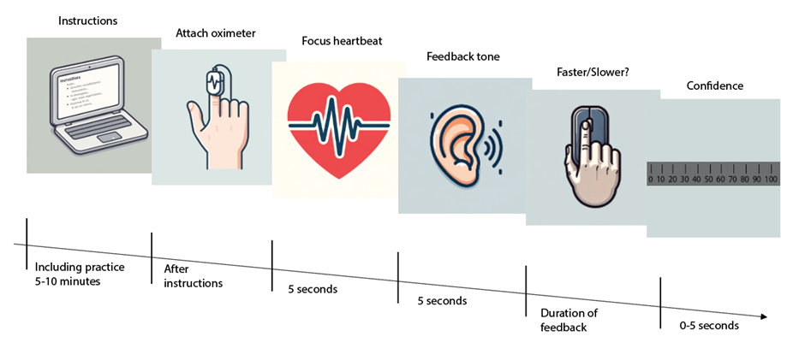
Figure 1: The ‘Cardioception’ task of heartbeat discrimination measuring interoceptive accuracy. Participants read instructions on a laptop, which instructed them to attach an oximeter clip to their finger. In the interoception condition, participants listened first to their heartbeat for 5 seconds and then to a series of tones. Then they rated whether the tones were faster or slower than their heartbeat. In the exteroception condition, listening to their heartbeat was replaced by listening to another external series of tones. At the end of the trial, they rated their response confidence with a sliding scale from 0 ‘guess’ to 100 ‘certain’.

Meditation Intervention Survey Analysis

General Linear Models
To assess whether the meditation intervention (CDM vs NDM) changed survey responses, we computed the difference between the scores after the CDM intervention minus after the NDM intervention. We then entered these difference scores into a linear regression controlling for intervention order:
CAPE (CDM minus NDM) ~ 1 + order (NDM first or CDM first)

The statistics of interest were the intercept which gave a p-value for any significant difference between CDM and NDM. The beta coefficient for ‘order’ gave a test for order effects. Including it in the regression, assured that main effects are not confounded by order effects

Controlling for Multiple Comparisons
Bonferroni Correction was applied to the results from the regression analysis. We were interested in the p values of the subscales indicating significance for the test of difference (intercept) r, meaning we had three tests for the main analysis (hypotheses 1-3) and sixteen for the exploratory analyses.

For the main analyses the significance threshold (for p<0.05 one-tailed) was therefore: α adjusted​= 0.05/3 ​=0.016

And for the exploratory analyses the significance threshold was: α adjusted​= 0.05/16 = 0.00313

Computing Bayes Factors
For hypotheses 1-3, we computed Bayes Factors using JASP, which quantifies the evidence for one hypothesis over another (JASP, 2024; Van Doorn et al., 2021).
The Bayes Factor (BF₀) was computed to assess the relative evidence for the null hypothesis (H₀: no difference) versus the alternative hypothesis (H₁: a one-tailed difference in scores as described in the hypothesis section in the end of the introduction). A default Cauchy prior was applied, and a Bayes Factor robustness check was performed to examine how different prior widths influenced the results.
Bayes Factors were interpreted using conventional thresholds, where values above 3 indicate moderate evidence for H₁, values close to 1 suggest inconclusive evidence, and values below 1/3 indicate moderate evidence for H₀.

Cardioception Task Analysis
In line with the procedure used by Legrand (2022), we first cleaned the data by removing outliers, which was conducted in Python using scripts provided by Legrand et al (2022). An analysis of outliers followed the method outlined by Legrand et al (2022), where trials with a reaction time of < 100ms were rejected. Trials with ‘unreliable heartbeat signal’ were also rejected, and this was calculated using absolute deviation around the median rule (Leys et al., 2013), meaning the average standard deviation of pulse-to-pulse intervals (from the oximeter readings). Mean outliers were calculated for the interoceptive condition across both the CDM and NDM blocks.

Modeling Interoceptive Accuracy
Analyse was done using statistical software R) and the R Stats Package from base R (R Core Team, n.d.), with the dplyr package used for data manipulation (e.g. making data frames and tidying data) (Wickham et al., 2023). First, a decision model was fitted for each participant as a logistic regression.

Decision (more/less) ~ 1 + decision_value

‘Decision (more/less)’ represents whether the participant decides the response stimulus is faster or slower than the stimulus in the listening phase (i.e. heart rate or speed of tone). ‘Decision_value’ represents the difference between the stimulus in the listening phase and the one in the response phase (in beats per minute, BPM). The beta weight for the ‘decision_value’ captures a participant’s sensitivity to the magnitude of the difference between the two stimuli. The intercept captures a participant's response bias, i.e. in general responding faster or slower. Before running the regression, predictive variable (decision_value) were z-score normalized to help model fitting. This was done across all participants, rather than within each participant to avoid introducing biases due to the adaptive staircasing nature of the task which meant that the decision values shown to participants were not necessarily the same.

We tested for group-level differences between the CDM and NDM session analogously to the analyses of the survey data:

Measure (CDM minus NDM) ~ 1+order

Our hypothesis for this was that NDM will be associated with a decrease in the strength of the influence of interoceptive signals to guide choices (whether feedback tone faster or slower). Here ‘Measure’ represents the sensitivity to ‘decision_value’ (decision_value beta weight), and ‘Order’ represents whether the participant received the CDM or NDM intervention first. We also computed Bayes factors, as described above.

Exploratory analysis - Confidence

An exploratory regression used the intercept (decision more/less). This analysis was performed separately for the interoception and exteroception conditions. We ran this analysis with non-absolute values (could be positive or negative) and with absolute values (all converted to positive values) for the decision bias. This allowed a measure for both the direction of the bias and a test of the overall magnitude of the bias.

As further exploratory analyses, we modeled participants’ confidence using a linear regression:
Confidence ~ abs(decision_value) + response (correct or false) + decision reaction time
‘Confidence’ was measured after each trial for both conditions, with a rating scale asking how confident the participant was with their decision (0 - 10). We include the ‘decision_value’ (sensitivity to the difference), whether they were correct or incorrect with their decisions on each trial and how quickly they responded (‘decision reaction time). We compared the effects of the interventions as described above.

Further control analyses – evidence for any use of the heart beat
To check whether the meditation intervention changed the overall heart rate, we computed for each participant, for each session the mean heart rate, and then compared this using regression analyses as described above, i.e. Heart rate (CDM minus NDM) ~ 1+order

As it turned out that the heart rates were in fact different between the sessions we performed additional control analyses, by repeating the regressions described above but including mean heart rate (difference between the CDM and NDM conditions) as an additional regressor.

To check whether the threshold estimated by the adaptive staircasing procedure was the same between sessions, we computed the average (signed and absolute) decision_value for the last 5 trials of each person in each session and compared them as described above.

We also performed several control regression models. We fitted:
Decision ~ 1 + decision_value (i.e. heart BPM listened to minus beep BPMlistened to) + (Heart BPM+beep BPM)/2
Decision ~ 1 Heart BPM+beep BPM

Because these models gave surprising results, we performed further control analyses. Specifically, we fitted hierarchical models, for all three decision regressions. In these hierarchical models, the impact of intervention and session order could be captured in three ways, which we will illustrate for the simples decision model:
Decision ~ (1 + decision_value) * (intervention + session [1st or 2nd]) + ( (1 + decision_value) * (intervention + session [1st or 2nd])|ID)
Decision ~ (1 + decision_value) * (intervention * session [1st or 2nd]) + ( (1 + decision_value) * (intervention * session [1st or 2nd])|ID)
Decision ~ (1 + decision_value) * (intervention * order[CDM or NDM first]) + (~ (1 + decision_value) * intervention|ID)
Described in words, we can either consider that intervention (CDM or NDM) and whether it is the first or testing session have independent or interacting effects. Or we can consider that the effect of intervention depends on the order of the interventions. Note that order is a between subject effect as each participant only has one assigned order.

The hierarchical models were fit using the BMRS [ref] package in Stan [ref]. We used 4 chains, with 2000 iterations (half of which warmup), and weekly informative priors for the regression weights of normal(0,3). We checked all Rhat< 1.1 and absence of divergent samples. Significance will be defined as the 95% Bayesian Credible Interval not including zero.

As the result of these analyses were surprising – suggesting that potentially participants did not at all use the heartbeat, we performed additional model comparisons. We hypothesized that participants could be using, instead of the heartbeat, just the auditory beep or just the current auditory beep, compared to previous beeps. To test this, we built several regression models and compared their fit to the data. As measure of fit we used the log likelihood as all models contained the same number of parameters. The models tested were all of the form: Decision ~ (1 + decision_value). With decision_value either being as defined above (auditory beep minus heartbeat) or defined as only the auditory beep. We did this separately for each person, for each modality, for each session. To draw conclusions, we then counted for how many participants which model provided the best fit.

As these results suggested that only a minority of our participants used the heartrate, we wanted to test whether this was a feature of our participants or also present in the original data. For this, we re-analysed data from [ref LEgradn] which originally established this task. We downloaded the openly available data (n= 218) and analysed it as follows: we excluded trials which were flagged as outliers (the original paper used the same procedure as described above and this was already included with their provided data). Then we fit the two models with the different ways of expressing decision value and compared their log likelihoods. We also fit the regression model including the heart rate and the auditory beep rate as separate regressors.

Results
The average age was 34.5 years (SD = 13.23), with 8 male participants (30.8%). Participants had an average meditation experience of 5.14 years (SD = 5.90), figure 2Ai+ii. Their reported meditation technique use varied (0-10 frequency score), with an average NDM use score of 1.52 (SD = 1.73), CDM use 4.08 (SD = 0.25), and ADM 2.21 (SD = 1.63), figure 2B. 12 participants (46.2%) completed the NDM block first (Table 1).

Table 1

Participant Demographics
 | Overall
n | 26
Education (%)
College 16-18 years A-Levels | 1 (3.8)
Some university 18+, no degree | 6 (23.1)
Trade or vocational | 1 (3.8)
Bachelor's degree | 5 (19.2)
Master's degree | 9 (34.6)
Doctorate | 4 (15.4)
Trauma (mean (SD)) | 3.65 (2.73)
this.session.type = Pre (%) | 26 (100.0)
Age (mean (SD)) | 34.58 (13.23)
Sex = Male (%) | 8 (30.8)
order = NDM.first (%) | 12 (46.2)
NDM use (mean (SD)) | 1.52 (1.73)
CDM use (mean (SD)) | 4.08 (2.35)
ADM use (mean (SD)) | 2.21 (1.63)
Employment (%)
Employed | 9 (34.6)
Homemaker | 1 (3.8)
Retired | 1 (3.8)
Self-employed | 4 (15.4)
Student | 10 (38.5)
Unemployed | 1 (3.8)
Mental Health (%)
Depression | 1 (3.8)
None | 24 (92.3)
Personality disorder | 1 (3.8)
Meditation duration (years) (mean (SD)) | 5.14 (5.90)

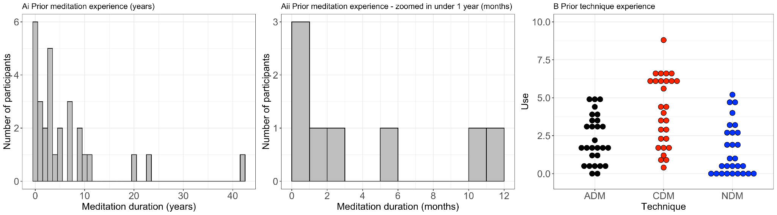
Figure 2: Meditation experience and technique use. From left to right, total meditation experience in years, meditation experience in months for participants with less than 1 years’ experience, meditation technique use divided by Nash et al’s (2013) 3 categories.

Survey Results
We hypothesised that self-inquiry (NDM) vs body-scan (CDM) meditation would increase psychotic-like experiences, mystical experiences and decrease self-reported interoception (one tailed tests, with corrected p-value cut-off = p = < 0.016). We could not reject any hypotheses (table 2, figure 3 +4) and in fact, we found evidence for the null hypotheses, quantified by Bayes Factors: psychotic-like experiences (p= 0.083 , Bayes Factor for null: 1.08, ‘Anecdotal’), mystical experiences (p =0.94, Bayes Factor for null: 6.49, ‘Moderate’) and interoceptive awareness (p = 0.210, Bayes Factor for null: 3.76, ‘Moderate’) (figure 4).
We also explored changes in any questionnaire subscales with the meditation interventions (two-tailed p-values in table 2, Bonferroni corrected cut-off: 0.00313). We found no evidence for any changes. We note that for interoception (MAIA), there was some evidence for an interaction between testing order and meditation type before correction but not after (p = 0.04 uncorrected).

Table 2

Survey Results
Questionnaire Totals | CDM, session 1 | NDM, session 1 | CDM, session 2 | NDM, session 2 | CDM minus NDM, mean(s.e.) | CDM minus NDM (p) | Order [NDM first], mean(s.e.) | Order [NDM first] (p)
CAPE Pos | 30.4 (5.3) | 30.9 (6.65) | 30.2 (8.71) | 30.8 (5.16) | 0.15 (0.7) | 0.83 | -2.06 (1.1) | 0.07
Mystical | 67.1 (27.5) | 54.8 (30.64) | 62.3 (38.41) | 66.8 (32.04) | -0.38 (5) | 0.94 | 4.75 (7.4) | 0.53
Interoception MAIA | 79.2 (17.96) | 69.1 (23.23) | 77.8 (26.03) | 84.9 (17.49) | -4.85 (3.7) | 0.21 | 12.3 (5.5) | 0.04
Decentering | 27.9 (6.8) | 24.0 (8.41) | 26.8 (9.97) | 29.6 (5.26) | -0.38 (1.3) | 0.77 | 1.66 (1.9) | 0.40
Interoception THISQ | 41.4 (10.38) | 47.6 (10.39) | 44.5 (13.51) | 46.7 (10.76) | -3 (2.5) | 0.24 | -3.09 (3.6) | 0.40
THISQ Cardiorespiratory Activation | 16.8 (4.74) | 18.4 (4.83) | 18.0 (4.11) | 18.9 (5.03) | -0.92 (1.1) | 0.4 | -0.36 (1.5) | 0.82
THISQ Cardiorespiratory Deactivation | 13.3 (4.63) | 16.4 (4.64) | 15.3 (5.16) | 15.4 (4.72) | -1.58 (1.2) | 0.21 | -0.23 (1.8) | 0.89
THISQ Gastroesophageal Sensations | 11.4 (4.18) | 12.8 (5.64) | 11.2 (6.42) | 12.4 (4.96) | -0.5 (1.1) | 0.65 | -2.5 (1.6) | 0.12
Mystical | 28.7 (15.73) | 24.2 (16.2) | 26.9 (20.17) | 27.6 (18.61) | 0 (2.5) | 1 | 0.64 (3.8) | 0.87
Mystical Positive Mood | 19.4 (6.15) | 16.2 (5.56) | 18.2 (7.42) | 21.0 (5.76) | -0.69 (1.2) | 0.56 | 1.87 (1.7) | 0.29
Mystical Space Time | 10.3 (7.62) | 8.4 (6.42) | 9.9 (8.56) | 9.9 (7.51) | -0.08 (1.3) | 0.95 | 1.08 (2) | 0.59
Mystical Ineffability | 8.7 (4.29) | 6.0 (4.69) | 7.3 (5.33) | 8.4 (5) | 0.38 (1.2) | 0.74 | 1.16 (1.7) | 0.50
MAIA Noticing | 13.3 (3.15) | 12.3 (3.39) | 13.4 (3.09) | 14.4 (2.68) | -0.69 (1) | 0.5 | 1.6 (1.5) | 0.29
MAIA Attention Regulation | 18.8 (6.29) | 16.4 (7.59) | 18.5 (9.18) | 18.8 (9.1) | -0.38 (1.1) | 0.74 | 2.11 (1.7) | 0.22
MAIA Emotional Awareness | 17.4 (3.65) | 15.8 (4.84) | 16.5 (3) | 18.0 (4.67) | -0.77 (1.1) | 0.48 | 1.59 (1.6) | 0.33
MAIA Self-Regulation | 12.6 (3.89) | 10.8 (4.61) | 11.5 (5.35) | 13.8 (2.55) | -0.62 (0.7) | 0.39 | 1.16 (1) | 0.28
MAIA Body Listening | 6.9 (3.15) | 5.7 (3.31) | 7.8 (3.89) | 8.5 (3.18) | -1.85 (0.8) | 0.02 | 3.66 (1.1) | 0.004
MAIA Trusting | 10.1 (3.46) | 8.1 (4.5) | 10.1 (4.8) | 11.4 (2.82) | -0.54 (0.6) | 0.4 | 2.17 (0.9) | 0.03
CAPE Bizarre Exps | 8.3 (1.82) | 8.6 (1.88) | 8.5 (2.5) | 8.4 (1.5) | 0.08 (0.2) | 0.75 | -0.53 (0.3) | 0.14
CAPE Persecutory Ideations | 7.7 (1.64) | 7.8 (2.38) | 6.9 (1.44) | 7.7 (1.33) | 0 (0.3) | 1 | -0.73 (0.5) | 0.13
CAPE Perceptual Anomalies | 3.2 (0.58) | 3.2 (0.58) | 3.4 (1.44) | 3.4 (0.93) | NA | NA | NA | NA
Note: Survey results divided by specific test and order of visit. For example, CDM session 1 indicates it is their first meditation block and they used the body-scan meditation which we classified as CDM according to Nash et al (2013) categories. CDM minus NDM represents the test for the effect of the meditation intervention, and order tests if there were any effects of the order the interventions were taken.

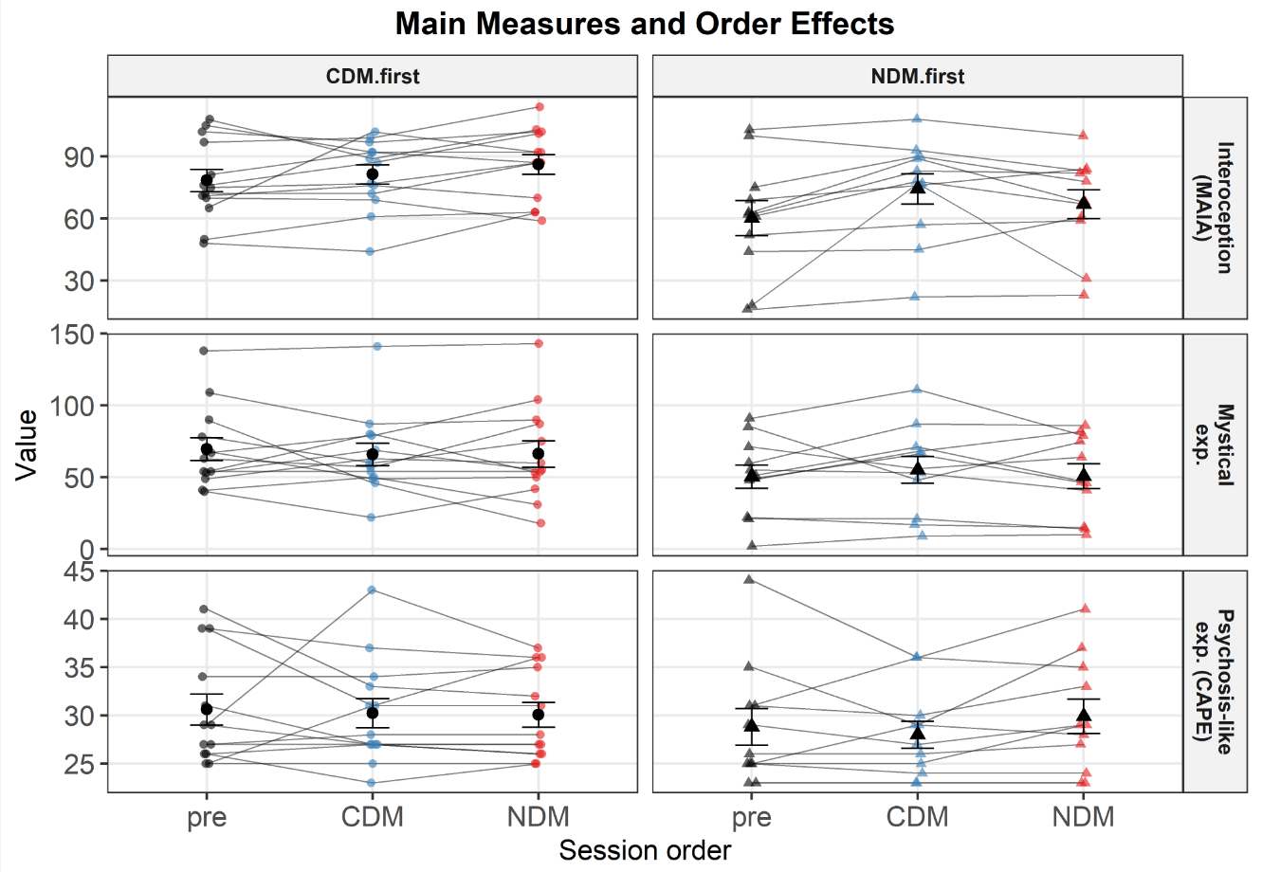
Figure 3: Self-reported interoception, mystical experiences and psychotic-like experiences. Plots show baseline totals (‘pre’), totals after the CDM meditation intervention (‘body-scan’) and after the NDM meditation block (‘self-inquiry’). These are divided by the order in which these were taken, with the scores for those who took the CDM intervention first on the left, and for the NDM intervention on the right. These represent totals from the questionnaire measures we used for our 3 main hypotheses (CAPE, Mystical Experiences Measure, MAIA2).

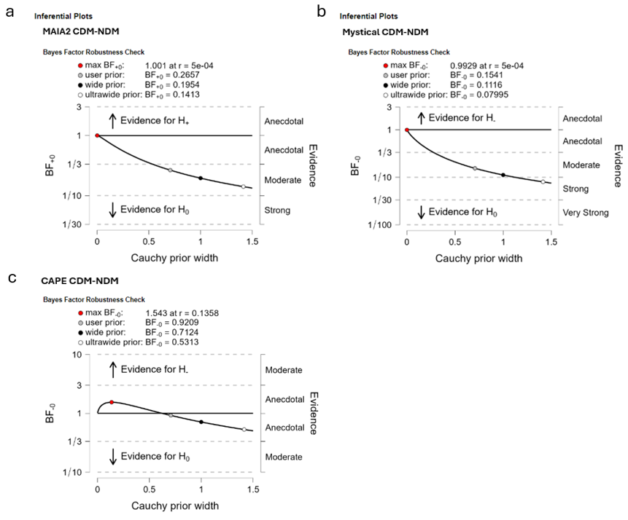
Figure 4: Bayes factor for self-reported interoception (MAIA2), mystical experiences and psychosis-like experiences (CAPE). For all three self-reports there was evidence for the null hypotheses (i.e. CDM compared to NDM did not increase interoception or decrease mystical experience or psychosis-like experiences). To assess sensitivity to prior assumptions, we conducted Bayes Factor robustness checks. Across all three measures (A, B, C), BF₀ values generally decreased as Cauchy prior width increased. For the MAIA 2 (A), the BF₀ was near 1 at a narrow prior, indicating inconclusive evidence. As the prior widened, BF₀ fell below 0.1, suggesting strong to very strong evidence for H₀. Similarly, for the Mystical Experiences Questionnaire (B), BF₀ decreased below 0.1 with wider priors, supporting strong to very strong evidence for H₀. In contrast, for the CAPE (C), BF₀ remained close to 1 across priors, indicating inconclusive evidence. The red = max Bayes factor, the grey dot = user prior (value reported in text), black dot = wide prior and white dot = ultrawide prior.

Overall, these results suggest that there is no evidence supporting differences between CDM and NDM conditions for CAPE positive symptoms, mystical experiences, or interoceptive awareness. Robustness checks confirmed that as prior width increased, support for the null hypothesis (no difference) became stronger, particularly for Mystical Experiences and the interoceptive measure (MAIA2) (Figure 4).

Cardioception Task Results

Interoception Decision
Overall, there were 24 participants with both sessions available for the interoceptive task analysis, with 120 trials per session. Participants performed a decision-making task testing their interoceptive ability. In the task, they needed to judge whether their own heartbeat was faster or slower than a subsequent tone series. In a comparison (‘exteroception’) condition, both stimuli to be compared were sounds. To test whether CDM vs. NDM meditation increased interoceptive ability, we fitted logistic regression models predicting responses as a function of stimulus difference (beats per minute, BPM) to each person’s decisions. The resultant regression weights (sensitivity to stimulus difference as well as a signed and absolute response bias) were then compared (CDM minus NDM condition) using regressions, controlling for order effects. Because the task schedule used to generate response stimulus (tone following the ‘listening’ phase) used an adaptive thresholding procedure, the schedules being shown to participants were not the same for individuals, nor were they the same across the interoception condition and the exteroception condition. Specifically, in the interoception condition the absolute difference in BPM between the two stimuli was larger and more variable than the exteroception condition (p<0.001), and at the same time participants overall give less correct responses (p<0.001).
Overall, participants performed the task well (Figure 5, table 4), modulating their responses by the stimulus difference, i.e. successfully detecting which sound train/ heartbeat was faster. Visual inspection suggests a strong overlap between the CDM and NDM meditation interventions for both the interoception and the exteroception conditions. To formally test this, we used regression models (figure 6A+C). We found no differences between the meditation interventions (Table 4, Figure 6).
There was no difference for sensitivity to the stimulus difference (p = 0.18, Bayes Factor for null: 0.19, ‘Moderate’) [main hypothesis] (figure 7), no difference in bias (select the first or second stimulus) (p =0.22 , Bayes Factor for null: 0.13, ‘Moderate’) and no difference in absolute bias (select one stimulus more than another) (p =0.32 , Bayes Factor for null: 0.23, ‘Moderate’).

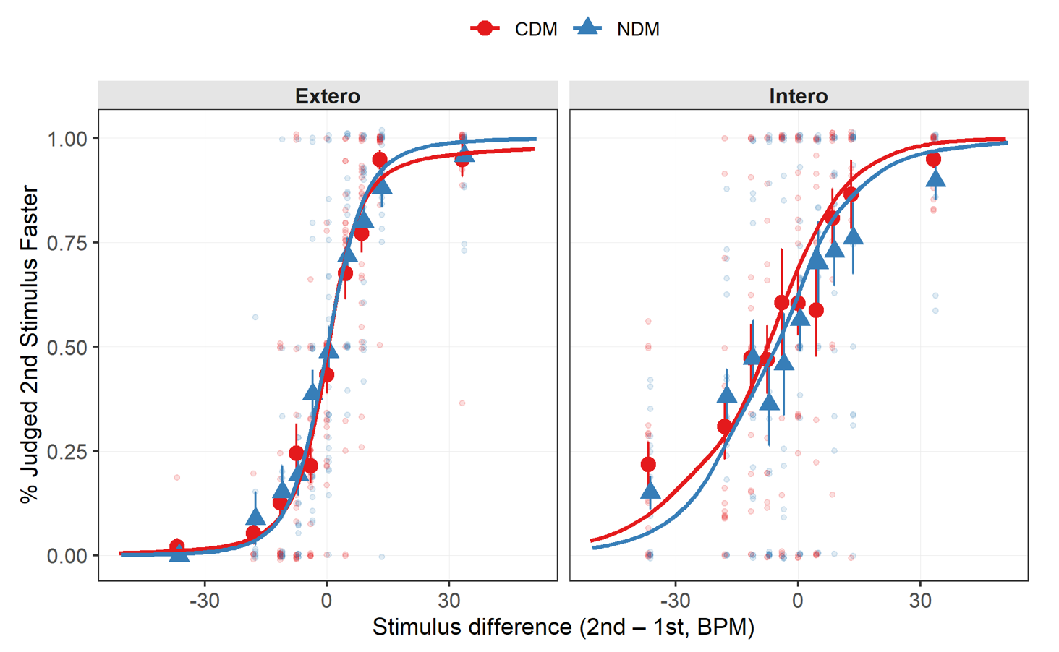
Figure 5: Difference between the stimulus in the listen phase versus that in the response phase (‘Stimulus difference’) of the Cardioception task. For ‘Extero’ (exteroception) both the listening and response phases were a tone. For the ‘Intero’ (interoception) participants listened/detected their heartbeats and for the response phase they listened to a tone. Negative values on the left of the x axis represent large negative differences between the stimuli, and vice versa on the right-hand side. The y axis represents values for the % participants judged the second stimulus (response phase) to be faster.

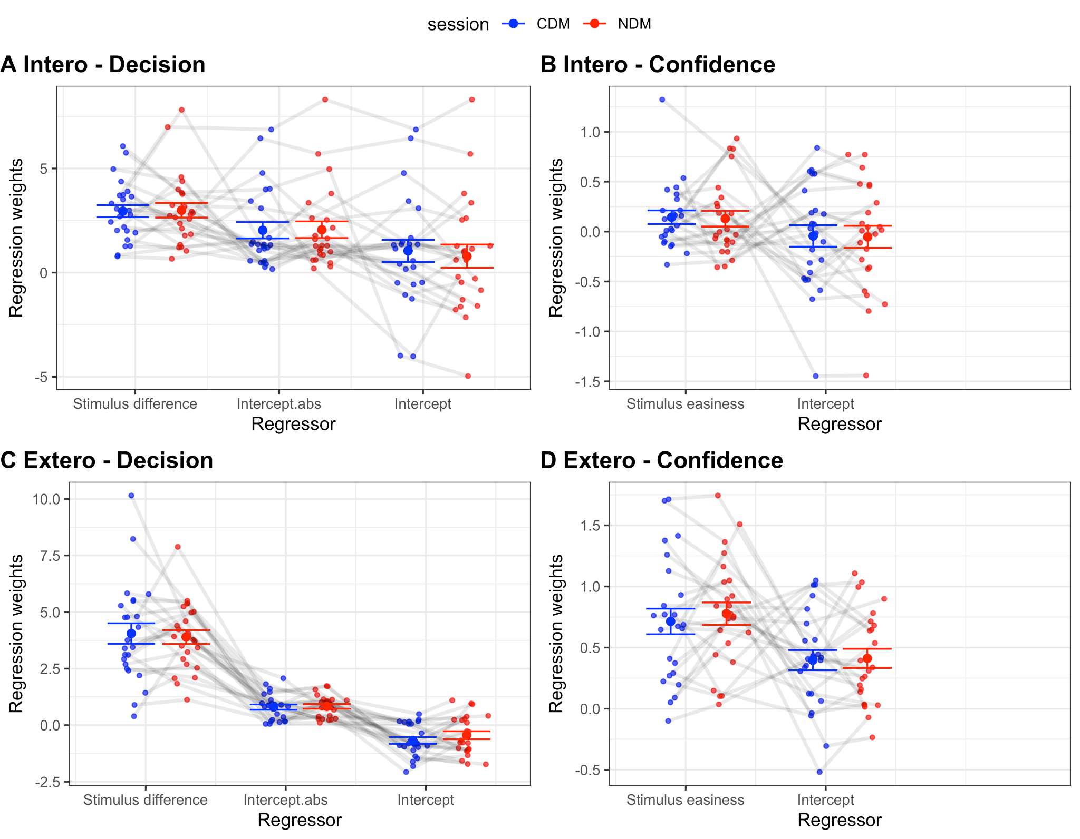
Figure 6: Regression weights for individuals across both interventions (CDM and NDM) and for both conditions (‘Intero’ = Interoception, ‘Extero’ = Exteroception). A and B show the Decision analysis, with ‘Stimulus difference’ (difference between 1st and 2nd stimulus), ‘Intercept’ (faster/slower) and ‘Intercept.abs’ (absolute version of faster/slower). B and D show the Confidence analysis (confidence in decision) with ‘Stimulus easiness’ (were they correct in decision) and ‘Intercept’ (confidence rating).

Table 4

Cardioception task glm results

Modality | Analysis type | Subject level regression weight | CDM & NDM (p, one-sample) | NDM vs CDM, mean(s.e.) | NDM vs CDM (p) | Order [NDM first], mean(s.e.) | Order [NDM first] (p)
Intero | conf | Intercept | 0.65 | -0.01 (0.1) | 0.92 | 0.04 (0.1) | 0.77
Intero | conf | Stimulus easiness | 0.03 | 0.06 (0.1) | 0.61 | -0.1 (0.2) | 0.56
Intero | dec | Intercept | 0.09 | 0.58 (0.5) | 0.22 | -0.71 (0.7) | 0.31
Intero | dec | Stimulus difference | <0.001 | -0.6 (0.4) | 0.18 | 1.21 (0.6) | 0.07
Intero | dec | Intercept.abs | NA | -0.43 (0.4) | 0.32 | 0.87 (0.6) | 0.17
Extero | conf | Intercept | <0.001 | -0.05 (0.1) | 0.62 | 0.07 (0.1) | 0.61
Extero | conf | Stimulus easiness | <0.001 | -0.12 (0.1) | 0.32 | 0.12 (0.2) | 0.5
Extero | dec | Intercept | <0.001 | -0.23 (0.3) | 0.38 | -0.01 (0.4) | 0.99
Extero | dec | Stimulus difference | <0.001 | 0.27 (0.6) | 0.65 | -0.25 (0.9) | 0.77
Extero | dec | Intercept.abs | NA | 0.08 (0.2) | 0.63 | -0.25 (0.2) | 0.33
Note: Results of the regression analyses testing decision and confidence with a comparison between interventions (‘NDM Vs CDM’) and combined results (NDM & CDM). ‘dec’ = decision, ‘stimulus difference’ = the beta weight for the difference between the 1st and 2nd stimulus, ‘intercept’ = the intercept for the regression, ‘conf’ = confidence, ‘stimulus easiness’ = regressor for correct responses for the confidence analysis (i.e. more correct means easier).

NEW TABLE
Modality | analysis.type | Subject.level.regression.weight | CDM min NDM, mean(s.e.) | CDM min NDM (p) | Order [NDM first], mean(s.e.) | Order [NDM first] (p)
Intero | dec | Intercept | 0.58 (0.5) | 0.22 | -0.71 (0.7) | 0.31
Intero | dec | Stimulus difference | -0.6 (0.4) | 0.18 | 1.21 (0.6) | 0.07
Intero | dec | Intercept.abs | -0.43 (0.4) | 0.32 | 0.87 (0.6) | 0.17
Intero | conf | Intercept | -0.01 (0.1) | 0.92 | 0.04 (0.1) | 0.77
Intero | conf | Stimulus easiness | 0.06 (0.1) | 0.61 | -0.1 (0.2) | 0.56
Extero | dec | Intercept | -0.23 (0.3) | 0.38 | -0.01 (0.4) | 0.99
Extero | dec | Stimulus difference | 0.27 (0.6) | 0.65 | -0.25 (0.9) | 0.77
Extero | dec | Intercept.abs | 0.08 (0.2) | 0.63 | -0.25 (0.2) | 0.33
Extero | conf | Intercept | -0.05 (0.1) | 0.62 | 0.07 (0.1) | 0.61
Extero | conf | Stimulus easiness | -0.12 (0.1) | 0.32 | 0.12 (0.2) | 0.5

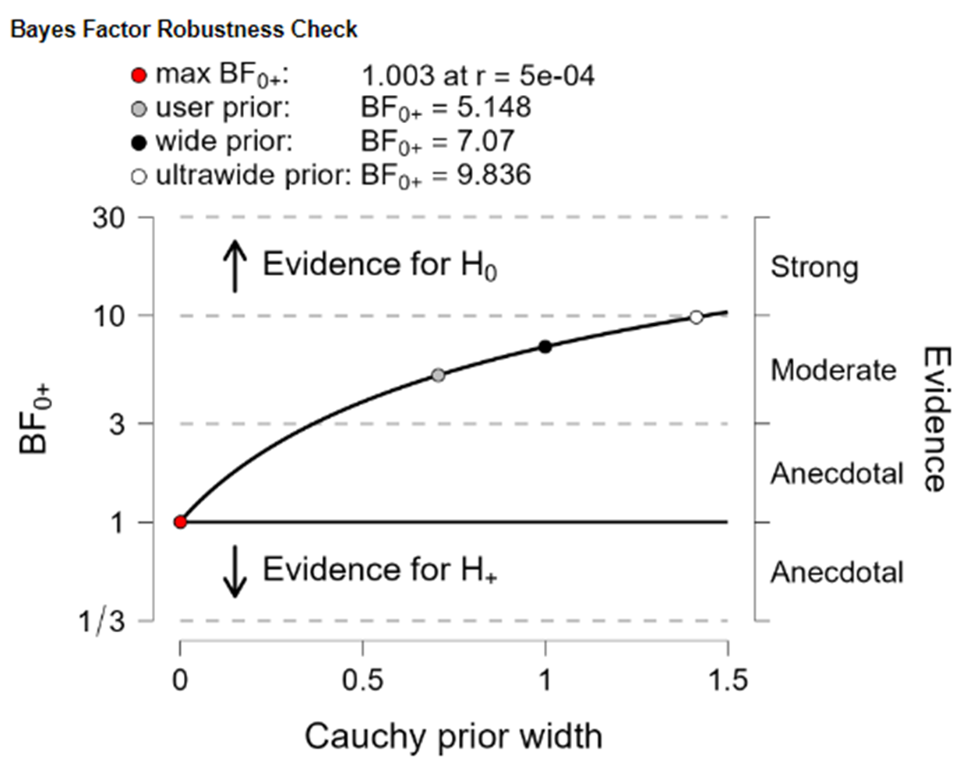
Figure 7: Result for the one sample Bayesian t-test for the main hypothesis for the Cardioception task. The statistic used is the sensitivity to the stimulus difference or ‘stimulus value’, for CDM - NDM. The red = max Bayes factor, the grey dot = user prior (value reported in text), black dot = wide prior and white dot = ultrawide prior.

Interoception Confidence
Across the two sessions, in both the interoception and the exteroception condition participants reported higher confidence when the trial was easier (extero: p < 0.001, intero: p=0.03, table 4 CDM & NDM). Comparing the meditation conditions (CDM minus NDM), we found no difference between them for interoception (p = 0.61) nor exteroception conditions (p = 0.65). There was also no difference between the meditation interventions for overall confidence (Intercept) (extero: p = 0.92, intero: p = 0.38, table 4).

Control analysis – differences in average heart rate
We tested whether participants differed in their average heart rate as a function of the intervention. For this we computed the average of heart rates across trials. We found that participants had a higher average heart rate in the CDM than the NDM condition (p=0.049 for the regression intercept, mean CDM: 76.4 BPM, mean NDM:72.7 BPM), in the absence of order effects (p=0.42).

Control analysis – threshold estimated by the adaptive staircasing procedure
To test whether the threshold estimated by the adaptive staircasing method during the task was different between the interventions, we computed, for each person and each session, the average decision value and absolute decision value of the last 5 trials. We found no effect of intervention for neither the signed decision value (regression intercept: p=0.81), nor the absolute decision value (p=0.1), in the absence of order effects (p=0.32 and p=0.30).

Control analyses – additional regression models and controls for average heart rate
We fitted additional regression models (table 5), in particular either replacing the decision value with its individual components (the heart rate BPM and the listened to BPM) or including in addition to the decision value the average of the heart rate BPM and the listened to BPM. Additionally, on the group level, for all decision models, we included participants average heart rate (CDM minus NDM session) as a control regressor to check whether it affected the difference between the interventions.

The only significant result (not correction for multiple comparisons) was surprisingly that when including heart rate BPM and listened to BPM separately, the NDM intervention showed a larger impact of listened to BPM than the CDM group (furthermore interaction with order). However, it is of note that this result was not found in the exteroception condition. It is also of note that this results was not found using hierarchical regression analyses (see below). On balance, changed sensitivity to listened to BPM for NDM vs CDM therefore does not seem to be a solid result.

Another striking result across all participants was that the regression weights for heart rate had the opposite sign of what we had expected (XXX) - they should be negative, indicating that the higher the heart rate, the more likely participants are to select the heart rate stimulus as the faster beep. This could suggest that participants did not use the heartrate to make their choice, we return to this below with analyses of model comparisons.

Including the average or standard deviation of heart rate (difference between CDM and NDM session) did not change any conclusions.
Modality | analysis.type | Regression weight | CDM min NDM (p) | Order [NDM first] (p) | CDM (estimate) | NDM (estimate) | CDM minNDM, ctr HR mean (p) | CDM minNDM, ctr HR sd (p)
Intero | Simulus difference (Sound bpm - Heart bpm) + Stimulus mean (Sound bpm + Heart bpm) | Intercept | 0.07 | 0.13 | 0.16 | 1.22 | 0.08 | 0.09
Intero |  | Stimulus difference (Sound-Heart) | 0.9 | 0.41 | 1.15 | 1.68 | 0.28 | 0.91
Intero |  | Sound+Heart | 0.11 | 0.02 | 4.41 | 4.23 | 0.7 | 0.1
Intero |  | Absolute of intercept | 0.31 | 0.12 | 2.57 | 2.52 | 0.41 | 0.28
Intero | Sound bpm + Heart bpm | Intercept | 0.07 | 0.13 | 0.16 | 1.22 | 0.08 | 0.09
Intero | Sound bpm + Heart bpm | Heart (bpm) | 0.39 | 0.07 | 1.06 | 0.46 | 0.75 | 0.37
Intero | Sound bpm + Heart bpm | Sound (bpm) | 0.007 | 0.004 | 4.13 | 4.67 | 0.04 | 0.005
Intero | Sound bpm + Heart bpm | Regr. weight diff (Sound minus Heart) | 0.7 | 0.58 | -3.07 | -4.21 | 0.21 | 0.71
Intero | Sound bpm + Heart bpm | Absolute of intercept | 0.31 | 0.12 | 2.57 | 2.52 | 0.41 | 0.28
Extero | Simulus difference (Sound bpm - Heart bpm) + Stimulus mean (Sound bpm + Heart bpm) | Intercept | 0.36 | 0.74 | -0.75 | -0.48 | 0.31 | 0.34
Extero |  | Stimulus difference (Sound-Heart) | 0.83 | 0.26 | 4.15 | 5.25 | 0.4 | 0.79
Extero |  | Sound+Heart | 0.39 | 0.45 | 0.82 | 1.5 | 0.59 | 0.37
Extero |  | Absolute of intercept | 0.83 | 0.16 | 0.94 | 1.18 | 0.81 | 0.88
Extero | Sound bpm + Heart bpm | Intercept | 0.36 | 0.74 | -0.75 | -0.48 | 0.31 | 0.34
Extero | Sound bpm + Heart bpm | Heart (bpm) | 0.98 | 0.28 | -3.65 | -4.39 | 0.42 | 0.94
Extero | Sound bpm + Heart bpm | Sound (bpm) | 0.73 | 0.26 | 5.59 | 7.35 | 0.41 | 0.69
Extero | Sound bpm + Heart bpm | Regr. weight diff (Sound minus Heart) | 0.82 | 0.26 | -9.24 | -11.74 | 0.4 | 0.78
Extero | Sound bpm + Heart bpm | Absolute of intercept | 0.83 | 0.16 | 0.94 | 1.18 | 0.81 | 0.88

[TABLE 5]

To follow-up these results, we performed hierarchical regression for all decision models, only for the interoception condition (table 6). In short, we found no significant impact of the intervention (CDM vs. NDM). We did find some evidence for testing order effects (session 1 vs session 2), specifically: In the regression including heart rate and sound beep rates as separate regressors, there was interaction between the sound beep rate and whether it was session 1 or session 2. For the question of whether participants really used the heart rate, the model including heart rate and sound beep rate as separate regressors found no significant impact of heart rate on the choice, again suggesting that participants did not use the heart rate to make their choices.

Heart bpm + Sound bpm model
 | Estimate | Est.Error | Q2.5 | Q97.5
Intercept | 0.15 | 0.41 | -0.65 | 0.98
Heart | -0.01 | 0.26 | -0.54 | 0.5
Sound | 2.98 | 0.32 | 2.38 | 3.66
Intervention | 0.32 | 0.31 | -0.29 | 0.94
Time | -0.17 | 0.31 | -0.75 | 0.47
Heart:Intervention | -0.13 | 0.33 | -0.8 | 0.51
Heart:Time | 0.1 | 0.37 | -0.62 | 0.86
Sound:Intervention | -0.08 | 0.3 | -0.69 | 0.52
Sound:Time | 0.64 | 0.34 | 0.01 | 1.37
Intervention:Time | -1.63 | 1.43 | -4.39 | 1.18
Heart:Intervention | -0.15 | 0.46 | -1.07 | 0.73
Heart:Time | 0.11 | 0.51 | -0.87 | 1.14
Sound:Intervention | -0.5 | 0.53 | -1.55 | 0.56
Sound:Time | 0.1 | 0.61 | -1.08 | 1.31
Heart:Intervention:Time | 0.12 | 0.89 | -1.62 | 1.84
Sound:Intervention:Time | 1.21 | 1.07 | -0.93 | 3.32
Intervention:Order | 0.34 | 0.58 | -0.8 | 1.45
Heart:Intervention | -0.01 | 0.41 | -0.78 | 0.81
Heart:Order | 0.03 | 0.47 | -0.89 | 0.93
Sound:Intervention | 0.36 | 0.36 | -0.33 | 1.09
Sound:Order | -0.33 | 0.6 | -1.51 | 0.85
Heart:Intervention:Order | -0.21 | 0.62 | -1.5 | 0.99
Sound:Intervention:Order | -0.61 | 0.45 | -1.53 | 0.26
(Heart bpm - Sound bpm) + (Heart bpm + Sound bpm)/2 model
Intercept | 0.07 | 0.41 | -0.72 | 0.86
Sound-Heart | 1.65 | 0.29 | 1.09 | 2.21
Sound+Heart | 1.99 | 0.29 | 1.44 | 2.6
Intervention | 0.32 | 0.29 | -0.26 | 0.92
Time | -0.13 | 0.31 | -0.7 | 0.52
Sound-Heart:Intervention | 0.01 | 0.32 | -0.6 | 0.63
Sound-Heart:Time | 0.37 | 0.37 | -0.31 | 1.11
Sound+Heart:Intervention | -0.21 | 0.32 | -0.84 | 0.41
Sound+Heart:Time | 0.54 | 0.35 | -0.1 | 1.3
Intervention:Time | -1.48 | 1.37 | -4.17 | 1.16
Sound-Heart:Intervention | -0.2 | 0.51 | -1.21 | 0.81
Sound-Heart:Time | -0.01 | 0.63 | -1.28 | 1.21
Sound+Heart:Intervention | -0.47 | 0.48 | -1.41 | 0.47
Sound+Heart:Time | 0.2 | 0.53 | -0.83 | 1.24
Sound-Heart:Intervention:Time | 0.73 | 1.1 | -1.43 | 2.86
Sound+Heart:Intervention:Time | 0.86 | 0.88 | -0.84 | 2.68
Intervention:Order | 0.26 | 0.57 | -0.88 | 1.41
Sound-Heart:Intervention | 0.27 | 0.36 | -0.44 | 1
Sound-Heart:Order | -0.21 | 0.59 | -1.36 | 0.97
Sound+Heart:Intervention | 0.19 | 0.39 | -0.53 | 0.98
Sound+Heart:Order | -0.16 | 0.48 | -1.1 | 0.79
Sound-Heart:Intervention:Order | -0.27 | 0.53 | -1.35 | 0.75
Sound+Heart:Intervention:Order | -0.57 | 0.56 | -1.71 | 0.45
Sound bpm - Heart bpm model
Intercept | 0.48 | 0.49 | -0.53 | 1.45
Sound-Heart | 2.88 | 0.29 | 2.32 | 3.5
Intervention | -0.27 | 0.33 | -0.92 | 0.38
Time | -0.41 | 0.34 | -1.09 | 0.26
Sound-Heart:Intervention | -0.07 | 0.28 | -0.6 | 0.49
Sound-Heart:Time | 0.56 | 0.34 | -0.07 | 1.26
Intervention:Time | -0.2 | 1.56 | -3.37 | 2.88
Sound-Heart:Intervention | -0.27 | 0.51 | -1.28 | 0.75
Sound-Heart:Time | 0.24 | 0.62 | -1.01 | 1.45
Sound-Heart:Intervention:Time | 0.69 | 1.11 | -1.45 | 2.91
Intervention:Order | 0.67 | 0.62 | -0.57 | 1.88
Sound-Heart:Intervention | 0.28 | 0.35 | -0.38 | 0.98
Sound-Heart:Order | -0.09 | 0.6 | -1.26 | 1.13
Sound-Heart:Intervention:Order | -0.49 | 0.47 | -1.45 | 0.46

Table 6. Results of the hierarchical regression analysis. Significance is defined as the 95% interval not including zero (highlighted in bold, i.e. the last two columns having the same sign).

Control analyses – Model comparisons
Above we reported the surprising result that participants might not use their heart rate to inform their choices. To quantify this more precisely, we performed model comparisons of three models that captured how participants could solve the task, one decision variable at the time (table XX, figure XX): as difference between the auditory beep rate and the heart rate (what they should do), comparing the sound beep rate to the average sound beep rate of the previous trials (here we arbitrary chose the previous 5 trials), using just the sound beep rate. We found (figure XX) that – no matter whether the data were split by intervention (CDM vs NDM) or by 1st vs 2nd session – in the exteroception condition, 88%-92% participants showed evidence of using both sound beeps to make their choice (vs. only using the second sound), while in the interoception condition, only 21%-33% of participants showed evidence of using the heart rate to guide their decisions.

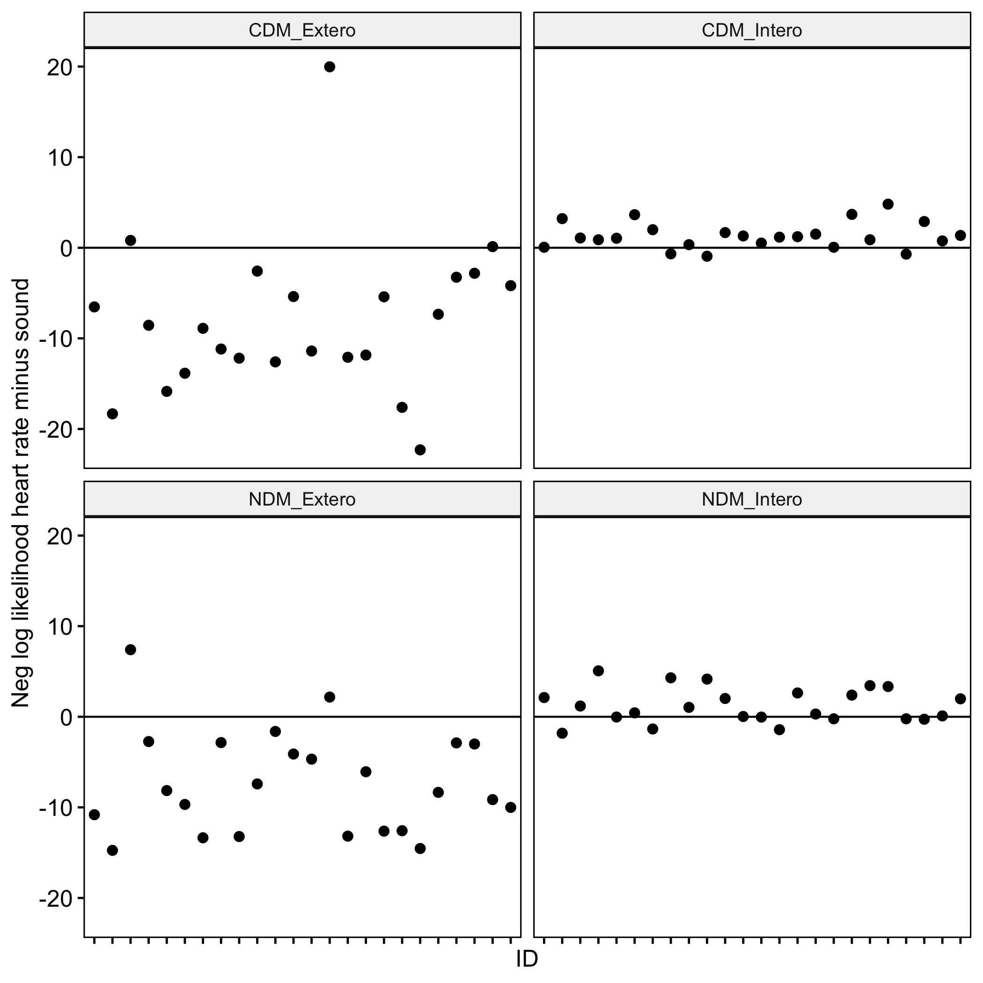

Control analyses – Behavioural re-analysis of original Legrand et al. data
Given the surprising results of little evidence for use of the heartrate when making choices, we wanted to test whether this was either due to problems this study’s participants had in performing the task or whether this feature was already present in the original validation paper [ref Legrand]. For this, we re-analysed the original data using the same approach. We found (figure XXA) that in the exteroception condition, the vast majority of particiapnts (88%) showed evidence of using both sound beeps to make their choice (vs. only using the second sound), while in the interoception condition, only 21% showed evidence of using the heart rate (comparing it to the second sound) vs just the sound. One possible explanation for this finding could be that in fact participants did use their heart rate, but because their heart rate (and thus the corresponding regressor) showed low variation, the task analysis looked like they were not taking into account their heart rate. We therefore tested correlations between evidence (log likelihood) for using the heart rate vs. for not using it with the standard deviation of the heart rate (fig XXB). Surprisingly, we found that the higher the heart rate standard deviation across the experiment, the less evidence that participants used the heartrate to drive their choices. One interpretation could be that when the variation in heart rate is lower, the model is better able to quantify that in fact participants did not use the heart rate.

We found similar results, when including the first (sound or heartrate) and second stimulus (sound) as separate regressors, in the exteroception condition both had a significant impact on choice (p<10⁻⁵⁶ for stimulus one and p<10⁻⁶⁵ for stimulus two), while in the interoception condition, the sound (p<10⁻³⁴), but not the heartrate had an impact on choice (p=0.44).

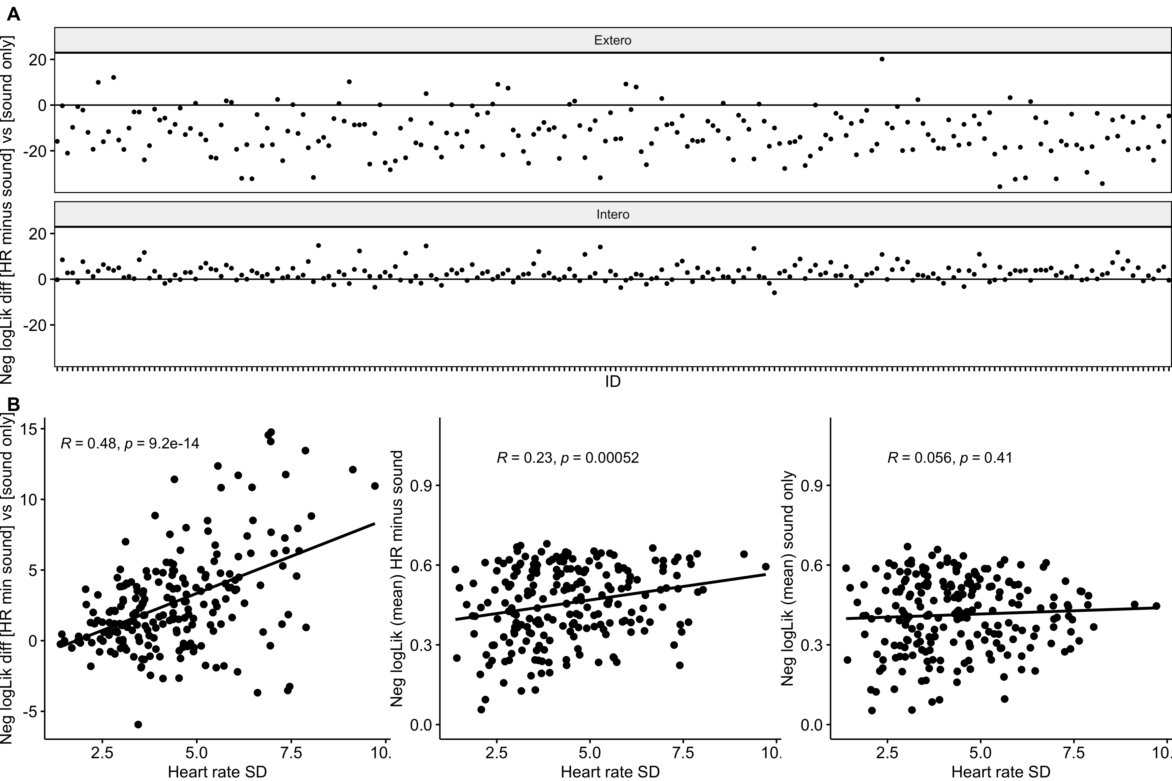
Figure XX. A) Negative log likelihoods comparing model fit of model predicting either choice as a function of the difference between the 2nd (sound beep rate) and the 1st stimulus (sound beep rate for exteroception condition or heart rate for interoception condition) or predicting choice as the 2nd stimulus sound beep rate only. Data from Legrand et al [ref]. Negative values suggest better fit of the model with the stimulus difference than the model with only the 2nd stimulus. B) Correlations between the standard deviation of the heart rate across the session and the (from left to right) [i] differences between the negative log likelihood of the model where the decision variable was as in A; [ii] negative loglikelihood for the model with HR minus sound; [iii] negative loglikelihood for the model with sound only. Note that for [ii] and [iii] the average log likelihood per trial was computed to correct for individual differences in the number of trials. Correlations are parametric, Pearson’s r.
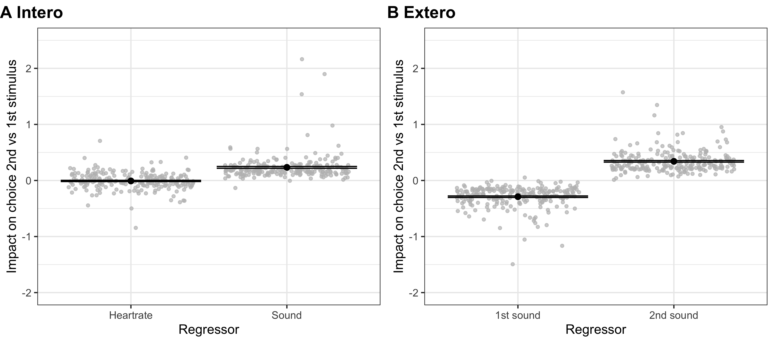
Figure XX. Results of the regression analyses predicting choice (2nd vs. 1st stimulus perceived as faster) based on including separately the rates (BPM) for the 2nd stimulus (‘2nd sound’ or simply ‘sound’ in the interoception condition) and the 1st stimulus (‘1st sound’ or ‘heartrate’ in the Interoception condition. Black dots show the mean and error bars the standard erorr of the mean; grey dots show individual participants’ regression weights. For all regressors apart from heart rate p<10⁻²⁰, for heart rate p=0.4). Data from Legrand [ref].

Discussion
In a within-subject counterbalanced meditation intervention study, we compared the effect of a body-focused meditation (body scan, CDM) and a less body-focused meditation (self-enquiry, NDM) on interoception ability, as well as self-reported interoception, psychotic-like symptoms and mystical experiences. We found no differences for any of these comparisons, nor for any further exploratory comparisons between other self-reports.

We categorised meditation techniques by the amount they focused upon bodily sensory signals (‘body focus’), an approach developed by Matko et al (2019), and by the goal of the ‘enhanced meditative state’ they sought to attain. The high body focused technique (body scan) was classified as a ‘cognitive directed method, according to our interpretation of Nash et al’s (2013) taxonomy,’ as it aimed to achieve an enhanced cognitive state, in this case a heightened awareness of the body. The second meditation technique was classified as low in body focus and as aiming at achieving a ‘non cognitive/non affective state’ (devoid of phenomenological content), fitting into the ‘null directed method’ (NDM) category of Nash et al’s (2013) taxonomy.

Meditation has been associated with challenging experiences (e.g. ‘particularly unpleasant’ and ‘psychotic-like) (Palmer et al., 2024; Schlosser et al., 2019), as well as benefits to mental health (e.g. Goyal et al., 2014; Zou et al., 2018). Interoceptive awareness has been associated with benefits to mental health (Nord & Garfinkel, 2022) and with the practice of techniques high in body focus (e.g. ‘body scan’ and ‘breath focused’) (Bornemann et al., 2015; De Jong et al., 2016; Fissler et al., 2016; Khalsa et al., 2020; Pérez-Peña et al., 2022) Interoceptive awareness is often measured using self-report questionnaire measures such as the Multidimensional Assessment of Interoceptive Awareness 2 (MAIA2) (Mehling et al., 2018). However, such self-report measures have been criticised for not measuring ‘interoceptive accuracy’ per se, and instead measuring interoceptive sensibility which is more a measure of attitudes towards interoceptive feelings and the body (Garfinkel et al., 2015). Legrand et al (2022) developed a lab-based test, that uses real-time heartbeat measurement with an oximeter, to test people's judgements of their own heartbeats. This ‘Cardioception’ task controls for the bias that self-report measures have, and instead utilises an approach to more objectively test people's accuracy at detecting the ‘beats per minute’ of their own hearts. This study set out to utilise the Cardioception task to investigate potential differences in the influence of two different meditation techniques upon peoples interoceptive accuracy. We predict the CDM (body scan) technique will improve interoceptive accuracy to a greater degree than the NDM (self-inquiry) technique. We employed self-report measures of beneficial traits (interoceptive awareness and decentering), as well as the Cardioception task of interoceptive accuracy. An intervention style approach was taken to allow for a better test of causality as compared to a single time-point survey approach.

As our key hypothesis for the Cardioception task, we tested whether a meditation with higher body focus (CDM) increased performance (i.e. better use of interoceptive information to guide choices). This was not the case, with Bayes factors indicating moderate evidence for the null hypothesis. In exploratory analyses, we tested the ‘bias’ in the direction of people's judgments (judging heartbeat is faster or slower than it was), and the confidence they had in their decisions or how their confidence was affected by the task difficulty. We also included a non-interoceptive control condition. We did not find any differences between CDM and NDM for any of these tests. Similarly, for the self-reported interoception, we found no differences between high and low body focus interventions. These results suggest that two weeks of high or low body focus meditation did not significantly influence decision bias within our study, nor confidence ratings of decisions made. Further exhaustive control analyses checked the perception threshold estimated by the adaptive staircasing procedure, performed different regression models, performed hierarchical regressions and additionally controlled for difference in the mean heart rate. All of these also failed to find evidence for an impact of the intervention on measures of interoception.

Mystical experiences and psychotic-like experiences (PLEs) have both been reported to involve alterations to the embodied self, including disrupted bodily boundaries and experiences of self-loss (Madeira et al., 2016; Stanghellini et al., 2012). PLEs are strongly associated with distress and dysfunction (Kelleher et al., 2015), compared to mystical experiences that are often reported as positive (Barrett et al., 2015; Roussel & Bachelor, 2000). However, it has been suggested that mystical experiences can also be distressing, and self-report measures such as the Mystical Experiences Questionnaire (employed in the current study) used to measure these experiences are generally biased towards capturing positive experiences (Taves, 2020). Despite the association with distress, both PLEs (Marriott et al., 2019) and mystical experiences can lead to transformative insights (Tassell-Matamua & Frewin, 2019).There is not a lot of research investigating how different techniques relate to challenging experiences (e.g. psychotic-like), and mystical experiences, but some evidence suggests that techniques that are low in body focus and classified as NDM might be more strongly associated with such experiences (Palmer et al., 2024). Therefore, our main aim was to test whether two techniques oppositely categories along a dimension of ‘body focus’ based on Matko and Sedlmeiers’ (2019) classification approach, and with different goals for the ‘intended end meditative state’ according to our interpretation of Nash et al’s (2013) taxonomy, were associated with challenging experiences (psychotic-like) and with traits associated with benefits to mental health (e.g. interoceptive awareness/accuracy). We did not find any significant results related to our analysis for PLEs or for mystical experiences. Results of the Bayesian One Sample t-test revealed ‘anecdotal’ evidence for the null hypothesis.

Limitations

The relatively short duration of the intervention (2 weeks per technique) is a possible weakness of the design of this study. Although some work suggests recordable changes in brain state using electroencephalogram (EEG) for novice meditators attending a three-day workshop (Stapleton et al., 2020), other work found a minimum of 8 weeks was necessary with a short daily practice (13 mins) to observe changes in emotional regulation (Basso et al., 2019). We used a guided audio track that participants listened to at home, but an alternative would be to use a meditation teacher to deliver the meditation. This might be achieved online (e.g. Zoom) if face to face was not practical. Strengths of this approach might include more engagement, and real time adjustment of instructions and feedback if required (e.g. if people do not understand or have doubts about how they are doing). We would therefore recommend a longer duration for the intervention and consideration of the use of a meditation teacher. Our sample contained a mix of people with little or no experience, those with some experience, and people with multiple years of experience. It might be insightful to divide people based on experience, for example including all those with very minimal experience in one group and those with multiple years in another. This would require a larger sample, or two separate studies to investigate better. Prior work has indicated differences between individuals in the effects of meditation upon mind wandering with concomitant EEG data, that suggests overall meditation experience is important (Rodriguez-Larios et al., 2021). Finally, closer analysis honing in on the impact of difference between the sound stimulus and the heart rate on choice vs. the impact of just the sound stimulus on choice revealed that this task might pose problems for many participants in using their heart rate to guide choices. Future research could consider alternative forms of interoception such as [ref Nikolova… Allen 2022].

Conclusion

In conclusion, our study does not provide evidence for improved interoceptive awareness after a two-week body scan meditation intervention vs. a two-week self-enquiry meditation intervention. Neither do we find evidence for any influences upon self-report measures of interoceptive awareness (MAIA2 and THISQ), mystical experiences or PLEs.

References
About Giovanni Dienstmann. (2024, March 22). Higher Mind. https://www.highermind.com/about-giovanni-dienstmann/
Audacity. (2020, April 13). Softonic. https://audacity.en.softonic.com
Barrett, F. S., Johnson, M. W., & Griffiths, R. R. (2015). Validation of the revised Mystical Experience Questionnaire in experimental sessions with psilocybin. Journal of Psychopharmacology, 29(11), 1182–1190. https://doi.org/10.1177/0269881115609019
Basso, J. C., McHale, A., Ende, V., Oberlin, D. J., & Suzuki, W. A. (2019). Brief, daily meditation enhances attention, memory, mood, and emotional regulation in non-experienced meditators. Behavioural Brain Research, 356, 208–220. https://doi.org/10.1016/j.bbr.2018.08.023
Bornemann, B., Herbert, B. M., Mehling, W. E., & Singer, T. (2015). Differential changes in self-reported aspects of interoceptive awareness through 3 months of contemplative training. Frontiers in Psychology, 5. https://doi.org/10.3389/fpsyg.2014.01504
Bornemann, B., & Singer, T. (2017). Taking time to feel our body: Steady increases in heartbeat perception accuracy and decreases in alexithymia over 9 months of contemplative mental training. Psychophysiology, 54(3), 469–482. https://doi.org/10.1111/psyp.12790
Brenner, K., Schmitz, N., Pawliuk, N., Fathalli, F., Joober, R., Ciampi, A., & King, S. (2007). Validation of the English and French versions of the Community Assessment of Psychic Experiences (CAPE) with a Montreal community sample. Schizophrenia Research, 95(1–3), 86–95. https://doi.org/10.1016/j.schres.2007.06.017
Dahl, C. J., Lutz, A., & Davidson, R. J. (2015). Reconstructing and deconstructing the self: Cognitive mechanisms in meditation practice. Trends in Cognitive Sciences, 19(9), 515–523. https://doi.org/10.1016/j.tics.2015.07.001
Dambrun, M., Berniard, A., Didelot, T., Chaulet, M., Droit-Volet, S., Corman, M., Juneau, C., & Martinon, L. M. (2019). Unified Consciousness and the Effect of Body Scan Meditation on Happiness: Alteration of Inner-Body Experience and Feeling of Harmony as Central Processes. Mindfulness, 10(8), 1530–1544. https://doi.org/10.1007/s12671-019-01104-y
De Jong, M., Lazar, S. W., Hug, K., Mehling, W. E., Hölzel, B. K., Sack, A. T., Peeters, F., Ashih, H., Mischoulon, D., & Gard, T. (2016). Effects of Mindfulness-Based Cognitive Therapy on Body Awareness in Patients with Chronic Pain and Comorbid Depression. Frontiers in Psychology, 7. https://doi.org/10.3389/fpsyg.2016.00967
Farias, M., Maraldi, E., Wallenkampf, K. C., & Lucchetti, G. (2020). Adverse events in meditation practices and meditation-based therapies: A systematic review. Acta Psychiatrica Scandinavica, 142(5), 374–393. https://doi.org/10.1111/acps.13225
Fischman, L. G. (2019). Seeing without self: Discovering new meaning with psychedelic-assisted psychotherapy. Neuropsychoanalysis, 21(2), 53–78. https://doi.org/10.1080/15294145.2019.1689528
Fissler, M., Winnebeck, E., Schroeter, T., Gummersbach, M., Huntenburg, J. M., Gaertner, M., & Barnhofer, T. (2016). An Investigation of the Effects of Brief Mindfulness Training on Self-Reported Interoceptive Awareness, the Ability to Decenter, and Their Role in the Reduction of Depressive Symptoms. Mindfulness, 7(5), 1170–1181. https://doi.org/10.1007/s12671-016-0559-z
Fox, K. C. R., Dixon, M. L., Nijeboer, S., Girn, M., Floman, J. L., Lifshitz, M., Ellamil, M., Sedlmeier, P., & Christoff, K. (2016). Functional neuroanatomy of meditation: A review and meta-analysis of 78 functional neuroimaging investigations. Neuroscience & Biobehavioral Reviews, 65, 208–228. https://doi.org/10.1016/j.neubiorev.2016.03.021
Fresco, D. M., Moore, M. T., van Dulmen, M. H. M., Segal, Z. V., Ma, S. H., Teasdale, J. D., & Williams, J. M. G. (2007). Initial Psychometric Properties of the Experiences Questionnaire: Validation of a Self-Report Measure of Decentering. Behavior Therapy, 38(3), 234–246. https://doi.org/10.1016/j.beth.2006.08.003
Garfinkel, S. N., Seth, A. K., Barrett, A. B., Suzuki, K., & Critchley, H. D. (2015). Knowing your own heart: Distinguishing interoceptive accuracy from interoceptive awareness. Biological Psychology, 104, 65–74. https://doi.org/10.1016/j.biopsycho.2014.11.004
Goyal, M., Singh, S., Sibinga, E. M. S., Gould, N. F., Rowland-Seymour, A., Sharma, R., Berger, Z., Sleicher, D., Maron, D. D., Shihab, H. M., Ranasinghe, P. D., Linn, S., Saha, S., Bass, E. B., & Haythornthwaite, J. A. (2014). Meditation Programs for Psychological Stress and Well-being: A Systematic Review and Meta-analysis. JAMA Internal Medicine, 174(3), 357–368. https://doi.org/10.1001/jamainternmed.2013.13018
JASP (Version Version 0.19.3). (2024). [Computer software]. JASP Team. https://jasp-stats.org/
Jonathan R. Krygier, James A. Heathers, Andrew H. Kemp, & Andrew H. Kemp. (2015). Mindfulness Meditation and Paying Attention to the Heart: Preliminary Findings Regarding Improvements in Interoception after 10-days Intensive Vipassana Meditation. ASP2015 - 25th Annual Conference of the Australasian Society for Psychophysiology. https://www.frontiersin.org/10.3389/conf.fnhum.2015.219.00026/event_abstract
Kelleher, I., Wigman, J. T. W., Harley, M., O’Hanlon, E., Coughlan, H., Rawdon, C., Murphy, J., Power, E., Higgins, N. M., & Cannon, M. (2015). Psychotic experiences in the population: Association with functioning and mental distress. Schizophrenia Research, 165(1), 9–14. https://doi.org/10.1016/j.schres.2015.03.020
Khalsa, S. S., Rudrauf, D., Damasio, A. R., Davidson, R. J., Lutz, A., & Tranel, D. (2008). Interoceptive awareness in experienced meditators. Psychophysiology, 45(4), 671–677. https://doi.org/10.1111/j.1469-8986.2008.00666.x
Khalsa, S. S., Rudrauf, D., Hassanpour, M. S., Davidson, R. J., & Tranel, D. (2020). The practice of meditation is not associated with improved interoceptive awareness of the heartbeat. Psychophysiology, 57(2). https://doi.org/10.1111/psyp.13479
Kontsevich, L. L., & Tyler, C. W. (1999). Bayesian adaptive estimation of psychometric slope and threshold. Vision Research, 39(16), 2729–2737. https://doi.org/10.1016/S0042-6989(98)00285-5
Launay, G., & Slade, P. (1981). The measurement of hallucinatory predisposition in male and female prisoners. Personality and Individual Differences, 2(3), 221–234. https://doi.org/10.1016/0191-8869(81)90027-1
Lebedev, A. V., Lövdén, M., Rosenthal, G., Feilding, A., Nutt, D. J., & Carhart-Harris, R. L. (2015). Finding the self by losing the self: Neural correlates of ego-dissolution under psilocybin: Finding the Self by Losing the Self. Human Brain Mapping, 36(8), 3137–3153. https://doi.org/10.1002/hbm.22833
Legrand, N., Nikolova, N., Correa, C., Brændholt, M., Stuckert, A., Kildahl, N., Vejlø, M., Fardo, F., & Allen, M. (2022). The heart rate discrimination task: A psychophysical method to estimate the accuracy and precision of interoceptive beliefs. Biological Psychology, 168, 108239. https://doi.org/10.1016/j.biopsycho.2021.108239
Leys, C., Ley, C., Klein, O., Bernard, P., & Licata, L. (2013). Detecting outliers: Do not use standard deviation around the mean, use absolute deviation around the median. Journal of Experimental Social Psychology, 49(4), 764–766. https://doi.org/10.1016/j.jesp.2013.03.013
Lindahl, J. R., Kaplan, C. T., Winget, E. M., & Britton, W. B. (2014). A phenomenology of meditation-induced light experiences: Traditional buddhist and neurobiological perspectives. Frontiers in Psychology, 4. https://doi.org/10.3389/fpsyg.2013.00973
Madeira, L., Bonoldi, I., Rocchetti, M., Samson, C., Azis, M., Queen, B., Bossong, M., Perez, J., Stone, J., Allen, P., Howes, O. D., McGuire, P., Raballo, A., Fusar-Poli, P., Ballerini, M., & Stanghellini, G. (2016). An initial investigation of abnormal bodily phenomena in subjects at ultra high risk for psychosis: Their prevalence and clinical implications. Comprehensive Psychiatry, 66, 39–45. https://doi.org/10.1016/j.comppsych.2015.12.005
Maharshi, R. (2024, March 15). Self Inquiry and Identity in Ramana Maharshis Who Am I. Ramana Maharshi. https://www.ramana-maharshi.org/self-inquiry-and-identity-in-ramana-maharshis-who-am-i/
Marriott, M. R., Thompson, A. R., Cockshutt, G., & Rowse, G. (2019). Narrative insight in psychosis: The relationship with spiritual and religious explanatory frameworks. Psychology and Psychotherapy: Theory, Research and Practice, 92(1), 74–90. https://doi.org/10.1111/papt.12178
Matko, K., Ott, U., & Sedlmeier, P. (2021). What Do Meditators Do When They Meditate? Proposing a Novel Basis for Future Meditation Research. Mindfulness, 12(7), 1791–1811. https://doi.org/10.1007/s12671-021-01641-5
Matko, K., & Sedlmeier, P. (2019). What Is Meditation? Proposing an Empirically Derived Classification System. Frontiers in Psychology, 10. https://doi.org/10.3389/fpsyg.2019.02276
Mehling, W. E., Acree, M., Stewart, A., Silas, J., & Jones, A. (2018). The Multidimensional Assessment of Interoceptive Awareness, Version 2 (MAIA-2). PLOS ONE, 13(12), e0208034. https://doi.org/10.1371/journal.pone.0208034
Melloni, M., Sedeño, L., Couto, B., Reynoso, M., Gelormini, C., Favaloro, R., Canales-Johnson, A., Sigman, M., Manes, F., & Ibanez, A. (2013). Preliminary evidence about the effects of meditation on interoceptive sensitivity and social cognition. Behavioral and Brain Functions, 9(1), Article 1. https://doi.org/10.1186/1744-9081-9-47
Mirams, L., Poliakoff, E., Brown, R. J., & Lloyd, D. M. (2013). Brief body-scan meditation practice improves somatosensory perceptual decision making. Consciousness and Cognition, 22(1), 348–359. https://doi.org/10.1016/j.concog.2012.07.009
Mossaheb, N., Becker, J., Schaefer, M. R., Klier, C. M., Schloegelhofer, M., Papageorgiou, K., & Amminger, G. P. (2012). The Community Assessment of Psychic Experience (CAPE) questionnaire as a screening-instrument in the detection of individuals at ultra-high risk for psychosis. Schizophrenia Research, 141(2), 210–214. https://doi.org/10.1016/j.schres.2012.08.008
Nash, J. D., Newberg, A., & Awasthi, B. (2013). Toward a unifying taxonomy and definition for meditation. Frontiers in Psychology, 4. https://doi.org/10.3389/fpsyg.2013.00806
Nash, J. D., & Newberg, A. B. (2023). An updated classification of meditation methods using principles of taxonomy and systematics. Frontiers in Psychology, 13. https://www.frontiersin.org/articles/10.3389/fpsyg.2022.1062535
Nikolova, N., Harrison, O., Toohey, S., Brændholt, M., Legrand, N., Correa, C., Vejlø, M., Jensen, M. S., Fardo, F., & Allen, M. (2022). The respiratory resistance sensitivity task: An automated method for quantifying respiratory interoception and metacognition. Biological Psychology, 170, 108325. https://doi.org/10.1016/j.biopsycho.2022.108325
Nord, C. L., & Garfinkel, S. N. (2022). Interoceptive pathways to understand and treat mental health conditions. Trends in Cognitive Sciences, 26(6), 499–513. https://doi.org/10.1016/j.tics.2022.03.004
Palmer, T., Kadri, K., Fakra, E., Scholl, J., & Fouragnan, E. (2024). Differential relationship between meditation methods and psychotic-like and mystical experiences. PLOS ONE, 19(12), e0309357. https://doi.org/10.1371/journal.pone.0309357
Pérez-Peña, M., Notermans, J., Desmedt, O., Van Der Gucht, K., & Philippot, P. (2022). Mindfulness-Based Interventions and Body Awareness. Brain Sciences, 12(2), 285. https://doi.org/10.3390/brainsci12020285
R Core Team. (n.d.). R: The R Project for Statistical Computing. R-Project.Org. Retrieved October 19, 2023, from https://www.r-project.org/
Rodriguez-Larios, J., Bracho Montes de Oca, E. A., & Alaerts, K. (2021). The EEG spectral properties of meditation and mind wandering differ between experienced meditators and novices. NeuroImage, 245, 118669. https://doi.org/10.1016/j.neuroimage.2021.118669
Roussel, J.-R., & Bachelor, A. (2000). Altered State and Phenomenology of Consciousness in Schizophrenia. Imagination, Cognition and Personality, 20(2), 141–159.
Schlosser, M., Sparby, T., Vörös, S., Jones, R., & Marchant, N. L. (2019). Unpleasant meditation-related experiences in regular meditators: Prevalence, predictors, and conceptual considerations. PLOS ONE, 14(5), e0216643. https://doi.org/10.1371/journal.pone.0216643
Stanghellini, G., Ballerini, M., Fusar-Poli, P., & Cutting, J. (2012). Abnormal Bodily Experiences May be a Marker of Early Schizophrenia? Current Pharmaceutical Design, 18, 392–398. https://doi.org/10.2174/138161212799316181
Stapleton, P., Dispenza, J., McGill, S., Sabot, D., Peach, M., & Raynor, D. (2020). Large effects of brief meditation intervention on EEG spectra in meditation novices. IBRO Reports, 9, 290–301. https://doi.org/10.1016/j.ibror.2020.10.006
Tassell-Matamua, N. A., & Frewin, K. E. (2019). Psycho-spiritual transformation after an exceptional human experience. Journal of Spirituality in Mental Health, 21(4), 237–258. https://doi.org/10.1080/19349637.2018.1481487
Taves, A. (2020). Mystical and Other Alterations in Sense of Self: An Expanded Framework for Studying Nonordinary Experiences. Perspectives on Psychological Science: A Journal of the Association for Psychological Science, 15(3), 669–690. https://doi.org/10.1177/1745691619895047
Van Doorn, J., Van Den Bergh, D., Böhm, U., Dablander, F., Derks, K., Draws, T., Etz, A., Evans, N. J., Gronau, Q. F., Haaf, J. M., Hinne, M., Kucharský, Š., Ly, A., Marsman, M., Matzke, D., Gupta, A. R. K. N., Sarafoglou, A., Stefan, A., Voelkel, J. G., & Wagenmakers, E.-J. (2021). The JASP guidelines for conducting and reporting a Bayesian analysis. Psychonomic Bulletin & Review, 28(3), 813–826. https://doi.org/10.3758/s13423-020-01798-5
Van Os, J., Linscott, R. J., Myin-Germeys, I., Delespaul, P., & Krabbendam, L. (2009). A systematic review and meta-analysis of the psychosis continuum: Evidence for a psychosis proneness–persistence–impairment model of psychotic disorder. Psychological Medicine, 39(2), 179–195. https://doi.org/10.1017/S0033291708003814
Vlemincx, E., Walentynowicz, M., Zamariola, G., Van Oudenhove, L., & Luminet, O. (2023). A novel self-report scale of interoception: The three-domain interoceptive sensations questionnaire (THISQ). Psychology & Health, 38(9), 1234–1253.
Wickham, H., François, R., Henry, L., Müller, K., Vaughan, D., Posit, & PBC. (2023). dplyr: A Grammar of Data Manipulation (Version 1.1.0) [Computer software]. https://CRAN.R-project.org/package=dplyr
Wießner, I., Falchi, M., Palhano-Fontes, F., Feilding, A., Ribeiro, S., & Tófoli, L. F. (2021). LSD, madness and healing: Mystical experiences as possible link between psychosis model and therapy model. Psychological Medicine, 1–15. https://doi.org/10.1017/S0033291721002531
Yaden, D., Haidt, J., Hood, R., Vago, D., & Newberg, A. (2017). The Varieties of Self-Transcendent Experience. Review of General Psychology, 21. https://doi.org/10.1037/gpr0000102
Zou, L., Yeung, A., Li, C., Wei, G.-X., Chen, K. W., Kinser, P. A., Chan, J. S. M., & Ren, Z. (2018). Effects of Meditative Movements on Major Depressive Disorder: A Systematic Review and Meta-Analysis of Randomized Controlled Trials. Journal of Clinical Medicine, 7(8), Article 8. https://doi.org/10.3390/jcm7080195

